Department of Computer Science and Engineering (Data Science)
S.Y. B.Tech. Sem: IV Subject: Statistics for Data Science
Experiment 5
Name: SAP ID:
Date: | Experiment Title: Confidence Interval
Aim | To implement Confidence Interval using Python.
Software | Google Colab
Theory | Explain the process of finding confidence interval.
Implementation | Using Python solve the following questions given below :  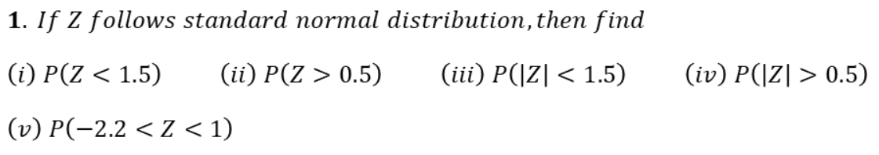  Code:  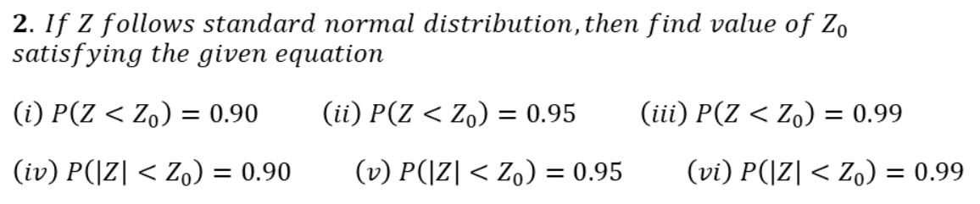  Code:  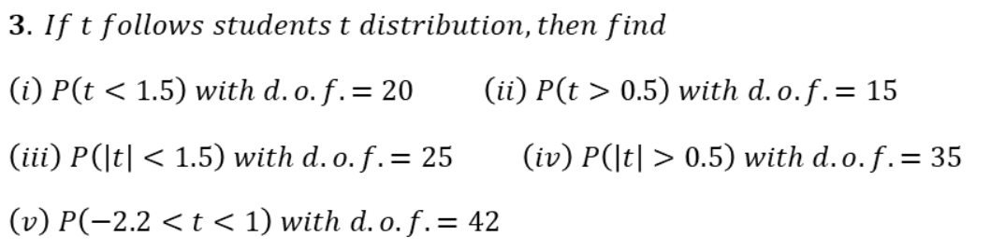  Code:  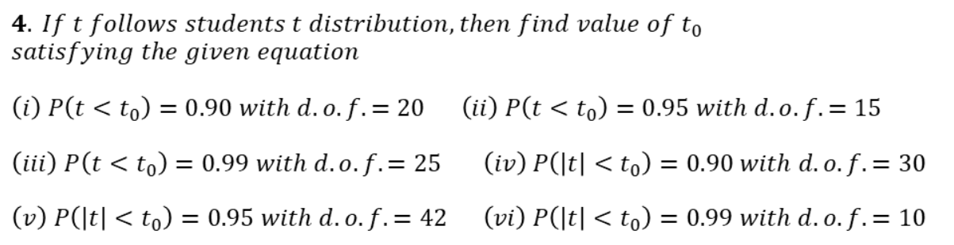  Code:  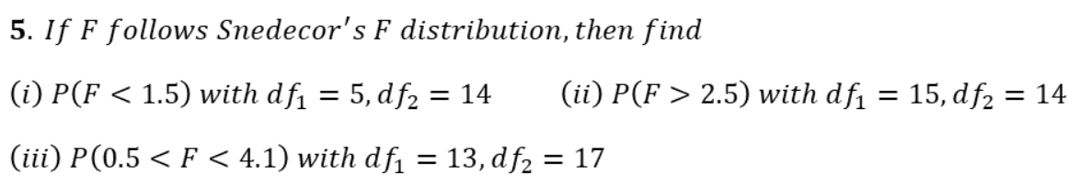  Code:  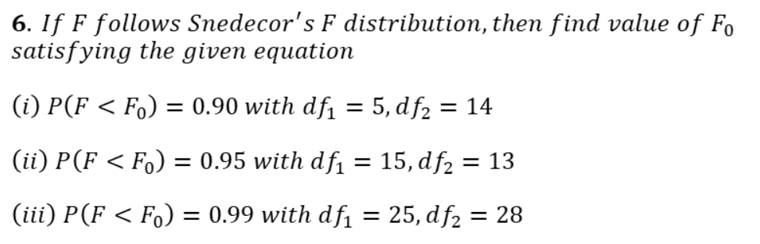  Code:  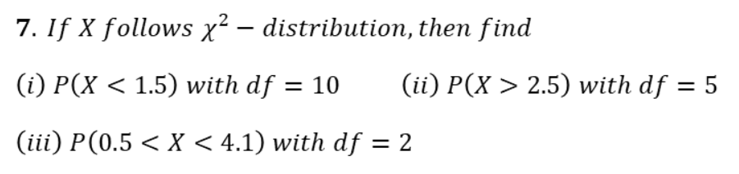  Code:  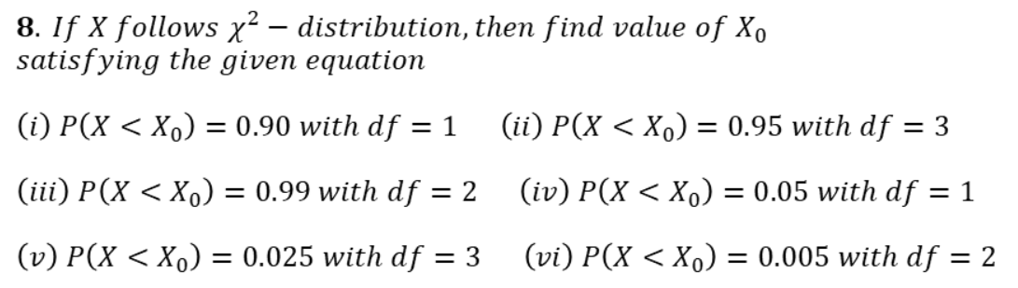  Code:  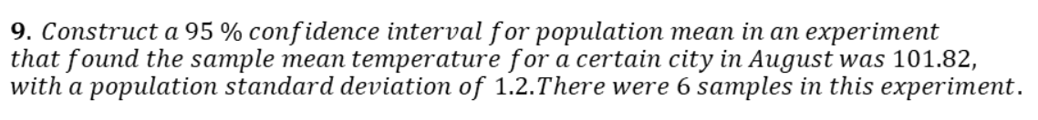  Code:  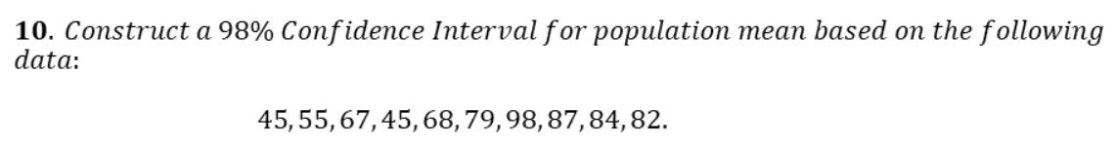  Code:  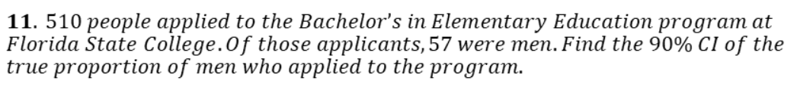  Code:
Conclusion | Thus, we studied how to implement Confidence Interval using Python.

Signature of Faculty

